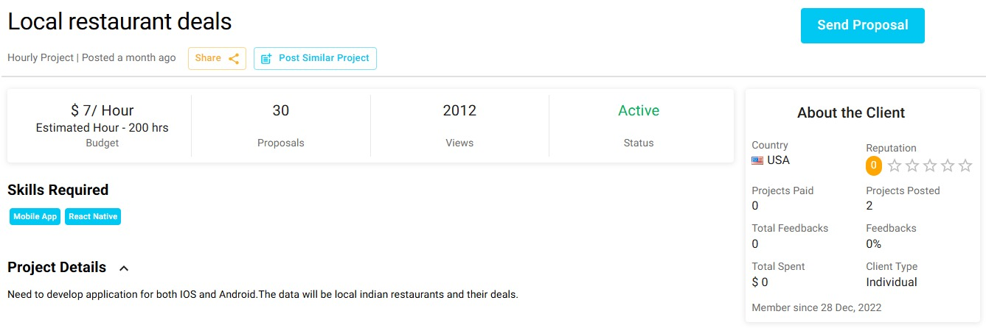

## **Overview**

Cross-platform mobile app (iOS & Android) showcasing local Indian restaurants and their deals.

## **Key Features**

- **User Side:**

- Browse restaurants & deals by location

- Search, filters, favorites

- **Admin Side:**

- Add/edit deals

## **Tech Stack**

- **Frontend:** React Native

- **Backend:** Firebase / Node.js

- **Maps:** Google Maps API

## **Timeline**

- Planning & Design: 3 Days

- Development: 1 weeks

## **Next Steps**

* Finalize design & start development.

Best Regards,

Muhammad Haseeb

https://github.com/xbugz-bunny